Motor Documentation

Degree of Motion
Robotic arms are typically engineered to enable movement along and rotation about multiple axes, which often necessitates the integration of several motors or actuators along the length of the arm. To avoid implementing unnecessarily complex systems solely to achieve specific striking motions, we consulted our padwork research to identify the required strike types. Our analysis determined that the essential movements about the joint are pitch and row, which can be accomplished with two motors providing these two degrees of motion.

Joint Design (Interim)
We have drawn inspiration from the following video (https://youtu.be/rP8Si_qXkzU) and selected a gear rail system for our design. This approach eliminates the need to mount a motor directly onto the moving arms; however, it introduces additional complexity due to the incorporation of a bevelled gear to facilitate pitch adjustment.
Using Solidworks, a 3D model of the design was created and iterated through.
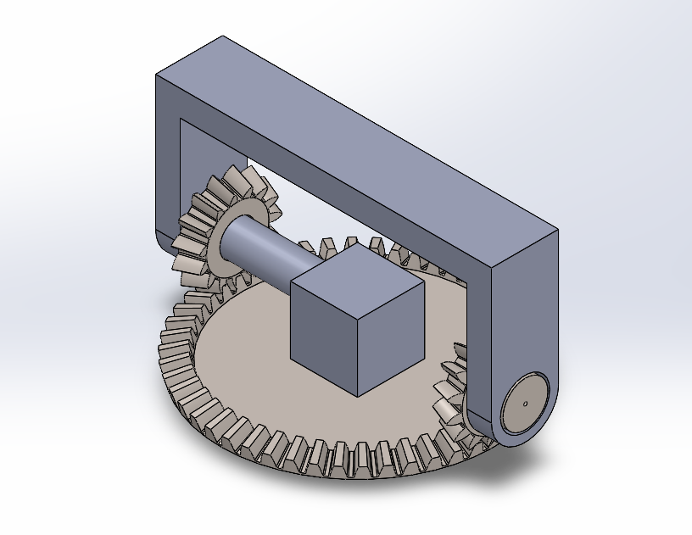 | 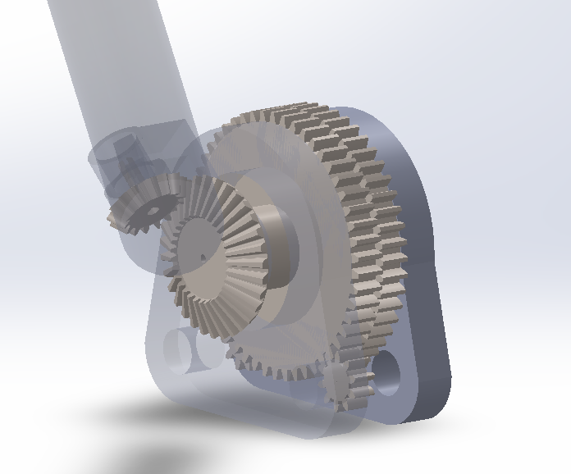 | 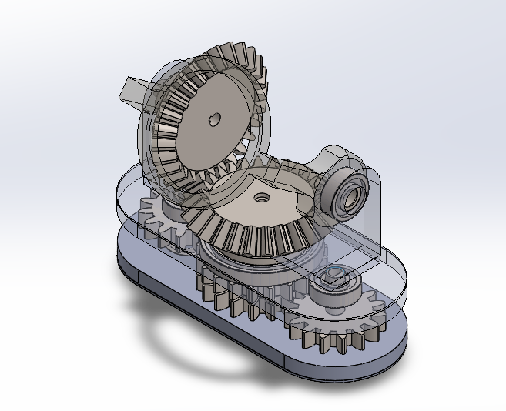
Label
Iterating through these designs provided insights into aspects of considerations when designing 3D parts. Parts not only need to fit, how the parts are eventually connected is also an important consideration during the design process.

Design Validation (Interim)
To valid that our design is truly able to execute the desired strikes, the final iteration was 3D printed using PLA filament. The joints provided the necessary degrees of freedom to achieve the desired strikes.

Design Considerations
During the interim presentation, our invigilator commented on two potential issues, backlash and damage due to impact.
Backlash is a common problem faced with gears where gaps within the teeth of the gears creates a lack of motion due to slackness when the motors reverse in direction. To reduce the amount of backlash, we have considered various options. Firstly, backlash can be reduced by decreasing the size of the teeth as an effort to reduce the gaps. Additionally, opting for helical gears would provide a more consistent pressure on the gears when rotating due to the slanted teeth on the gears. Alternatively, the gears can be replaced with timing belts for better accuracy and a reduction to backlash.
Damage to motors from impact is often caused by a sudden stop experienced by the motors. If the arm joint is not designed to be flex or bend during impact, the resistance will feedback into the gears and ultimately the motors. In the previous box bunny, the arm joints were directly mounted to servo motors. When subjected to impacts to the arm joints, the gears within the servo motors often wear down and break. Replacing the motors with brushless DC motors would help improve motor longevity as the motors do not rely on gears and can freely spin when pressure is exerted onto the motors. As we also required accuracy when rotating our joints, the motor control must also be precise and has internal feedback loop for position control.

Motors
Brushless DC motors are often found commonly in drones and RC cars. These motors are designed specifically to spin a wheel or propeller at a certain speed. They are typically controlled with an electronic speed controller (ESC) and which prioritize high RPM, however it generates lower torque at slower speeds. To ensure that the torque the motor can achieve is consistent at all speeds, Field Oriented Control (FOC) provide efficient control and more consistent torque. To achieve an efficient control of the motors, precise feedback of the motor position must be provided via an encoder attached to the motor.

Controller
We have selected the Odrive V3.6 and a 360KV drone motor as our initial testing set up.

